**Assignment 2**

**Humber Number – N01539697**

**Name – Surya Karan Sharma**

Complete the following steps and take screenshot of the outcome of each step:

Step1: Create new Node/Express app as follow:

• Create new folder named “Asn2-yourname”.

• Change directory to “Asn2-yourname”:

• Open terminal and run npm init

• In the terminal run: npm install express --save

• In the terminal run: npm install express-handlebars --save

• Make sure to have the following project structure:

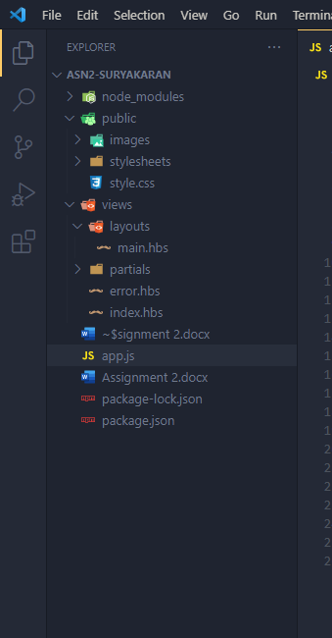

Step2: Using the attach file (codenippet.txt), copy/paste the related code to “style.css”,

“main.hbs”, “index.hbs”, “error.hbs” and “app.js”.

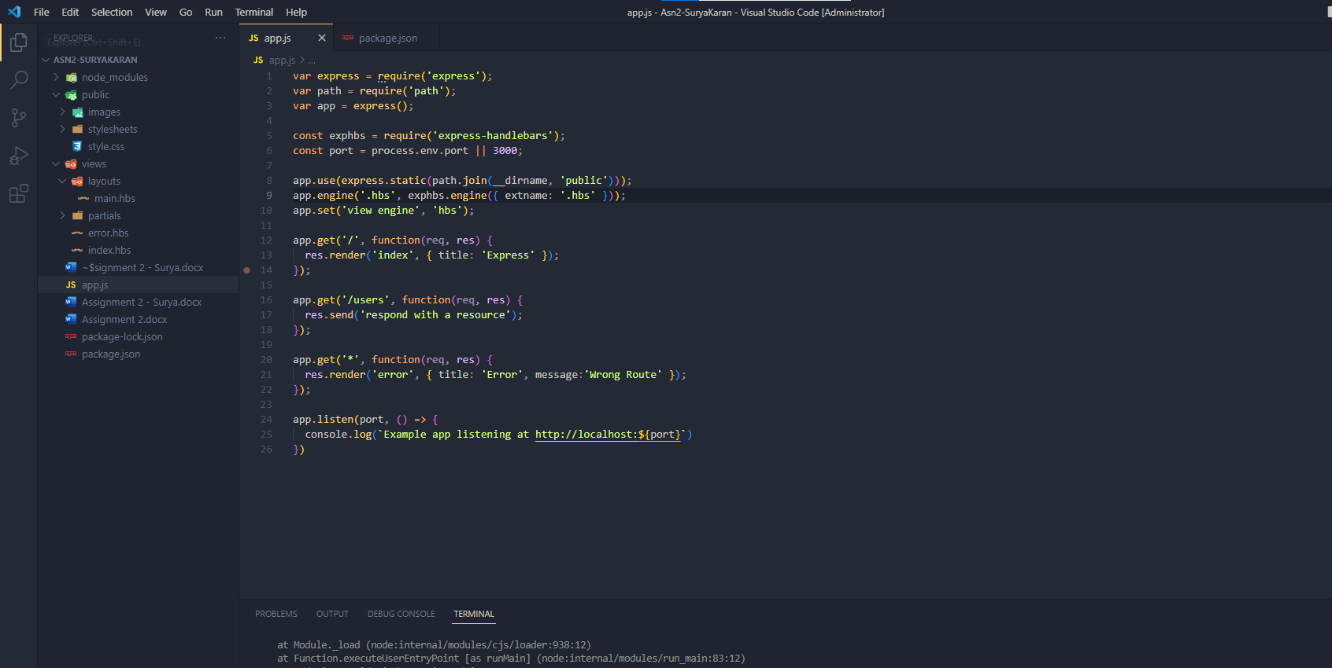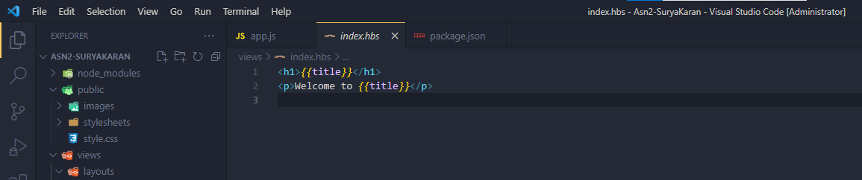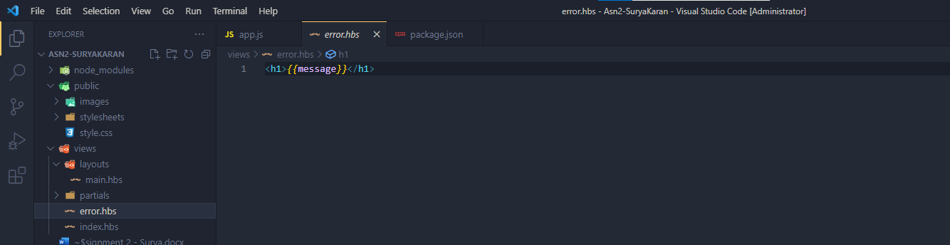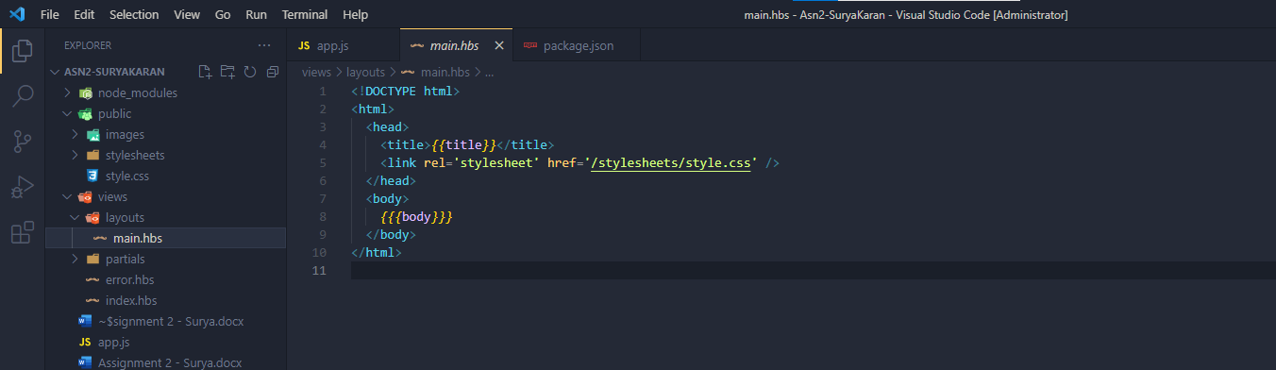

Step 3: Run the application and test it using the following routes:

* <http://localhost:3000/>

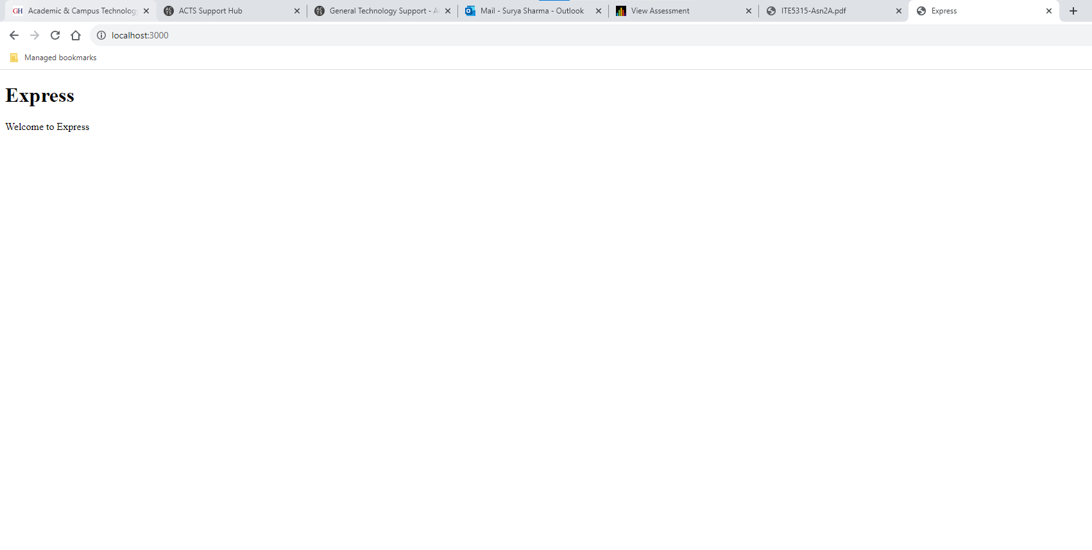

* <http://localhost:3000/users>

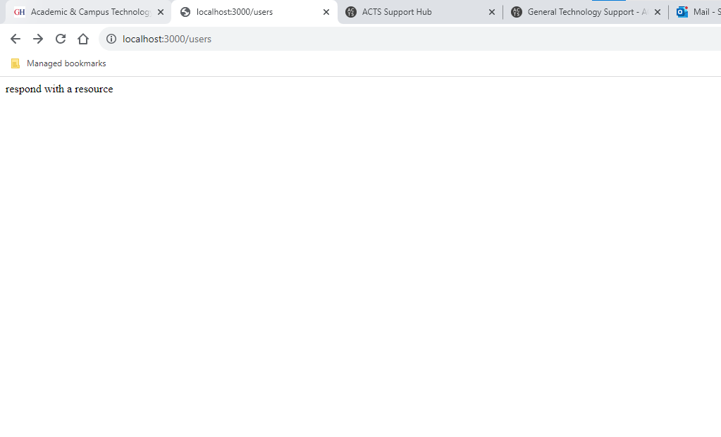

* <http://localhost:3000/notExist>

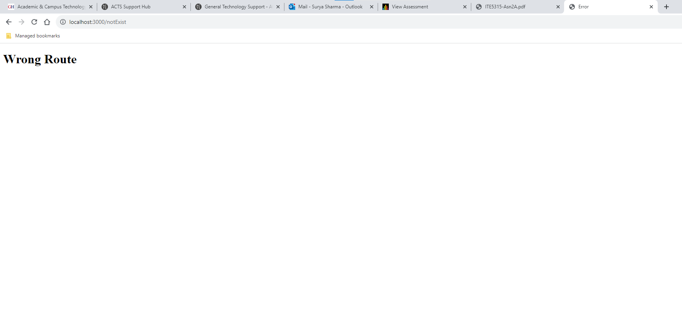

Step 4: Base on your observation, answer the following questions:

a) What is the role of “main.hbs”? How does it being used/called in the app?

b) What is the role of “index.hbs” and “error.hbs”? How do these files being used/called in

the app?

c) In “app.js”, what is the role of the following line? What happen if you commend it out?

ITE5315 Page 3/4 Professor: Shahdad

app.use(express.static(path.join(__dirname, 'public')));

d) Try to add proper comments to each line/block in app.js

Step 5: Modify the layout of the page and add “header”, “content” and “footer” as follow.

• Add your name/std_id to the header

• Add your email address to the footer

• The other dynamic contents/messages should be displayed in the “content” area.

• Use your creativity to add proper css style/format. Add

(hint: you need to redesign main.hbs and style.css)

Step 6: Add the Assignment1 code into this template. So the assignment1 form and output

should be displayed in the content area of the layout.

• For each of the route in assignment 1 (like /data, /data/invoiceNo/{index},

/search/invoiceNo/, /search/ Manufacturer/), you need to create a related “page” in

“/views” folder. So, when the “app.get” of the related route is called, you gonna use the

proper “res.render(‘page’, {data})”. (hint: use similar ideas like index.hbs) Moreover,

you also should redesign the way that you generate output in Assingment2 by displaying

the output using Handlebars expression/helpers.

Step 7: Design a new route “/allData” to display all Sales info in html table output using

handlebars helpers/expression.

ITE5315 Page 4/4 Professor: Shahdad

Step 8: Modify Step 7 (change the endpoint/view name) by removing those records which their

“class” is blank (hint: use “#if” helper ☺)

Step 9: Design a custom helper for changing “blank” to “unknown” for records which their

“class” is “blank”. Apply this on Step7&8 in order to display all data but highlight those rows

that their “class” is “blank”!

Step 10: Any idea how to do any of the followings:

A. You want to change table row color for those records which “class” is “blank”. Any way

that you can implement it using Template Engine? Explain your answer

B. In this app, do you find any use cause for utilizing “Partial” Templates? Explain your

answer

• Bonus: implement your idea of A and B!

Step 11: Deploy the app to Vercel.